International Operations Presentation – Part 2

DUE DATE: October 9, 2018

PowerPoint presentation to class on the date scheduled, business casual attire, approximately 15-20 minutes. Project to be uploaded to Blackboard on or before due date. Late projects will have significant point reductions.

The project rubric will be distributed in two parts. This document is PART 2, describing the Proforma Invoice (formal quotation to your buyer) and overall presentation guidelines. Detailed description below.

Project potential points, 100 total

For your potential buyer overseas, prepare a Proforma Invoice (separate word file or part of the PowerPoint) for a reasonable product order. Proforma Invoice template provided by instructor. The Proforma Invoice should include:

Date
Seller and buyer details (name, address)
Quantity, unit price, extended price, total CIP price
CIP Incoterm
Product description and harmonized tariff code, country of origin
Payment term
Price validity (expiration of quotation), lead time
Currency
Freight Resources: www.fedex.com, Quick Access Get Rates and Transit Times for air; www.freight-calculator.com/; estimate $4000-5000 per container for ocean shipments)
Cargo insurance (estimate $0.50 per $100 of cost of goods plus freight)
Destination Control Statement (provided on template)

Estimate Landed Cost which should include:

Extended price (unit price x number of units sold)
Freight (truck, air or ocean)
Cargo Insurance
Import duties in foreign country, Value Added Tax (VAT) (if applicable), other customs fees or taxes (if applicable) (Customs Info Database http://export.customsinfo.com/, log in using instructor email, sdragotta@wctc.edu)
Total estimated landed cost (add all above items)

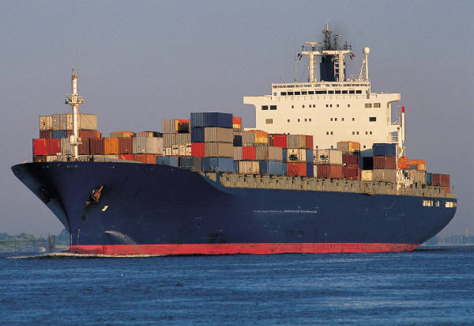



Dimension | Description | Comment | Points
Proforma Invoice  23 points | Include in your PowerPoint presentation or as a separate Word document.  Proforma includes accurate:  Date, seller/buyer details (2 pts)  Quantity, unit price, extended price, total CIP price  (3 pts)  CIP Incoterm (4 pts)  Product description and harmonized tariff code, country of origin (4 pts)  Payment term (2 pts)  Currency (2 pts)  Transportation method (2 pts)  Expiration date of quotation and lead time (2 pts)  Destination Control Statement (2 pts)
Landed cost analysis  7 points | Estimated landed cost including cost of goods, freight, insurance, import duties, Value Added Tax, if applicable, other taxes/fees that may apply  (this should be separate from the Proforma invoice)
Presentation  12 points | Ability to answer questions from classmates (2 pts)  Professional PowerPoint slides (2 pts)  Quality of sources used (listed) (3 pts)  Clear voice, loud enough and slow enough to be understood, appropriate language (2 pt)  Eye contact with audience (1 pt)  Approximately 15-20 minutes in length (1 pt)  Business casual attire (1 pt)
Organization  6 points | Logical progression of ideas and supporting information  (3 pts)  The text has no spelling/grammar errors (3 pts)
BONUS | Above and beyond effort bonus (4 pts)
Part 2 – 48 points
Total potential points 100 (without BONUS) including both parts of rubric.

